“Holding the First Arab Forum about Higher Education in Cooperation with Jordan” says the University President
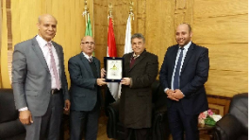
Prof.Dr. El-Sayed El-Kady, the university president hosts prof.Dr. Ghaleb Orikat, the vice president of Amman University, prof.Dr. Sakr EL-Khrabsha, the head of the oval office of university studies in Jordan. The meeting is held in the presence of prof.Dr. Mahmoud Eraqi, the dean of the faculty of agriculture, prof.Dr. Abd- Allah Saad, the manager of the new programs in the faculty of engineering/Shubra, some representative of the civil society from the peasants union to discuss the possibility of scientific and academic cooperation between both universities. The university president asserts that the possibility of holding the first Arab forum of higher education between Egypt and Jordan in cooperation with Benha university to discuss higher education-related issues, its problems, its challenges, scientific research, the international ranking of the universities and the new scientific programs stressing that this forum will be held in Egypt.

