“The University Leaders are chosen according to Efficiency” says the University President

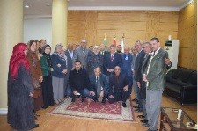
Prof.Dr. El-Sayed EL-Kady, the university president asserts that the old concepts of labor should be changed to turn the society from consummation to production. The university president stresses on labor creativity and the importance of youth talk as every manager should hold a monthly meeting with his employees to communicate with them. The university president adds that the university leaders are chosen according to efficiency. This statement concurs with the university president meeting with the secretaries of the faculties and the CEOS. At the end of the meeting, the university president honors the secretaries of the faculties, who retired on pension, for their exerted effort in the service of the university.

