Prof.Dr. Abd-El-Kader Ibrahim is the General Coordinator of the Quality Management Units in the University

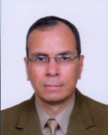
Benha University congratulates Prof.Dr. Abd-El-Kader Ibrahim, the professor at the mechanical engineering in the faculty of engineering/ Shubra on being the general coordinator of the quality management units in the university wishing him success and prosperity in his new position.

