Benha University Council honors the Winners in the International Contest for Robots in India

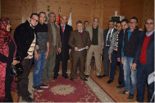
Benha university council honors, in its session on Tuesday evening under the presidency of prof.Dr. El-Sayed El-Kady, five students from the faculty of engineering- Benha who obtains the sixth position at the international contest for Robots in India. This contest lasted for three days with nine Arab and foreign countries represented by 12 teams. The students were overjoyed by the praise that was heaped on them by prof.Dr. Gamal Ismail, the vice president of the community service and environment development, prof.Dr. Hesham Abu- Enin, the vice president of post-graduate studies and research and the faculties’ deans.

