The University Council honors the Winners in the International Programming Contest in Finland

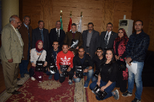
The university council honors the winners of the international programming contest that was held in the capital, Heliniski and lasted for three days in the last November. There were 1000 students from 428 European and American universities who participated in this contest. Benha university team obtained the second place in the contest. The honored students are the following; Bassem Ehab, Muhammad Sakr, Muhammad Abd-el-Nabi, Hesham Osman and Muhammad Ehab from the faculty of engineering/ Shubra in addition to Nourhan Radwan and Mirna Soliman from the faculty of applied arts.

