The End of the Faculties’ members and employees league in Benha University

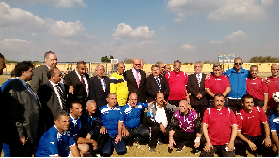
Prof. Dr. El-Sayed EL-Kady, the university president attended the end of the Faculties’ members and employees league in Benha University. This event was attended by the deans of the faculties, the faculties’ members, the university’s general secretary and the university’s employees. The university handed the medals and the league cup to the faculties’ members team that won the match. Mr. Mahmoud Abd-El-Aziz, the head of the employees club in the university gives Prof. Dr. El-Sayed EL-Kady, the university president the armor of the club praising what the university president do in order to link the faculties’ members with the employees.

.

