The Result of the International Publishing Contest of July 2016

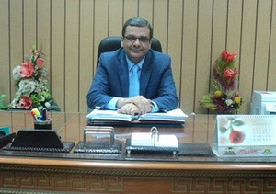
Prof. Dr. Hesham Abu El-Enin, the vice president of post-graduate studies and research stated that, under the auspices of Prof. Dr. El-Sayed EL-Kady, the university president, the supreme committee of the international ranking of the universities endorsed, in its last meeting, the report of the technical committee to examine the scientific production of the faculties’ members which was published in the international scientific periodicals at the third round that consists of 160 researches. The grievances will last for 10 days after the result of examination is announced via the e-mail Vp.pg@bu.edu.eg. It is important to say that the results will be announced again after the end of the grievances.

.

