«Private Businesses are the future» says the University President

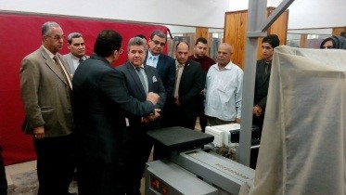
Prof. Dr. EL-Sayed EL-Kady, the university president attends the inauguration of the first scientific forum at the faculty of physical education. The inauguration was attended by prof. Dr. Gamal Ismail, the vice president of community service and environment development, prof. Dr. Hesham Abu- El- Enin, the vice president of post-graduate studies and research, prof. Dr. Ezat EL-khait, the head of staff members club at the university and several students and professors. Prof. Dr. Ghada Amer, the professor of electro-engineering speaks about the innovation and creativity of the youth urging the students at the faculty should enhance their innovative abilities and create a suitable environment for inventors and creators in all fields. The university president asserts that innovation is important and students have to create new jobs by setting up small companies that provide services to the community. At the end of the forum, the university president honors the winners who achieve sport accomplishments around the world.

.

