Prof. Dr. Muhammad Ghanem is the Head of the Third Session of the Accreditation, Quality management and Research

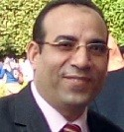
Benha University congratulates Prof. Dr. Muhammad Ghanem on being the head of the third session of accreditation, quality management and research. This promotion is in the frame of 8th international conference of the Arab organization of quality management in education which will be held at the American University in Beirut, Lebanon from 1-12-2016 to 2-12-2016.

.

