«Draw a Smile» exhibition to be held in the faculty of Education

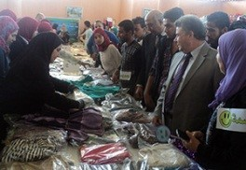
In order to draw a smile on the students’ faces in the faculty of education, Prof. Dr. El-Sayed EL-Kady, the university president inaugurates, on Sunday, 27-11-2016, “Draw a smile” exhibition to provide students with clothes. The exhibition was inaugurated in the presence of prof. Dr. Gamal Ismail, the vice president of community service and environment development, prof. Dr. Hesham Abu El-Enin, the vice president of post-graduate studies and research and prof. Dr. Ibrahim Fouda, the faculty’s dean. Prof. Dr. Eman Abd EL-Haq, the faculty’s deputy of community service and environment development indicates that this exhibition includes 780 pieces of clothes and the university president orders that all things will be sold at the cost of 5 L.E to release the burden over the students’ shoulders. The earnings of the exhibition will go to the incapable students at the faculty.

