The university president cares for health awareness of the university students

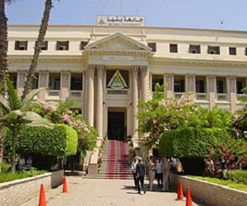
The University president Prof. Dr. El-Sayed EL-Kady stresses that health awareness of the university students should be taken care of by holding forums under the auspices of the sector of community service and environment development in the university’s faculties such as facilities of arts and nursing. Prof. Dr. Howyda sadik, the dean of the faculty of nursing says that there will be a forum about the general health awareness of the students.

