Cooperation Agreement between Benha University and International Studies at China

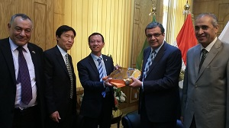
Prof. Dr. Hesham Abu El Enin, Benha University Vice-president for Postgraduate Studies and Researches' Affair has signed Memorandum of Understanding with the President’s Deputy of International Studies University Dr. Hi Jin Beaw. In his word, Prof. Dr. Hesham Abu El Enin has praised the strong relations between Egypt and China at all fields. The Chinese delegation has visited faculty of Arts and the new Chinese department to follow up status of students’ in presence of Prof.Dr. Abeer El Rabbat, the Faculty dean.

