Prof. Dr. El Sayed Yusuf El Kady inspects Faculties of Veterinary Medicine and Agriculture

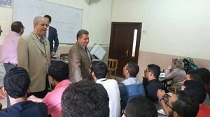
Prof. Dr. El Sayed Yusuf El Kady, the President of Benha University inspected study halls at faculties of Veterinary Medicine and Agriculture in 27\9\2016 in presence of Prof. Dr. Mahmoud Iraqi, Faculty of Agriculture dean and Dr. Mahmoud Salem, Faculty of Veterinary Medicine Dean. The University President congratulated students on occasion of the new academic year 2016\2017 and encouraged them to do their best to achieve their goals.

