Benha University President heads the Council of Open Education

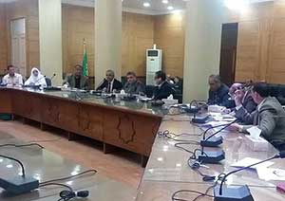
Prof. Dr. Sayed El Kady, the President of Benha University heads the council of open education in presence of deans and the general secretary of the University to discuss admission and transfer date. The University president has approved the required numbers of students for the academic year 2016/2017. Dr. Ezzat El Khayat, the manager of open education declared that the University president has accredited results of the 1st semester.

