Benha University Council thanks the E-portal for their Excellence in Webometrics 2016
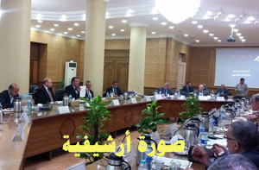
During the meeting of Benha University Council in 31/07/2016; Prof. Dr. Ghazy M.R. Assassa, the Advisor to Benha University President for Information Technology and the University Chief Information Officer “CIO” praised the excellence of the e-portal in Webometrics, July 2016.
It is worth mentioning that Benha University e-portal has got the fourth place at the level of the Egyptian public universities and the fifth place at the level of the Egyptian public and private universities.

