Benha University keeps its Rank between Top 100 Arab Universities in QS Rankings 2016

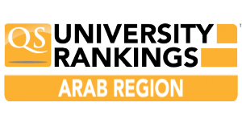
The British Company “Quacquarelli Symonds” (QS) has announced its ranking of 2016 on Tuesday, 14/06/2016 and even though the strong competition this year between more than 300Arab Universities (public and private), Benha University has kept its rank between top 100 of the best Arab Universities according to QS ranking for the Arab region 2016.

