Workshop on “How to apply for Projects financed by Newton/Moshraffa Fund”

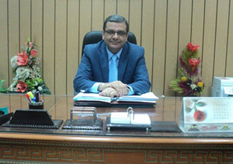
Prof. Dr. Hesham Abu El Enin, the University Vice-president for Postgraduate Studies and Researches’ Affairs has announced the University will hold a workshop for the young researchers about “How to apply for Projects financed by Newton/Moshraffa Fund” with cooperation of the British Council in Egypt on Wednesday, 04/05/2016 at the Conferences Hall in the faculty of commerce.
It is worth mentioning that the workshop will be held under the auspices of Prof. Dr. Ali Shams El Din, the President of Benha University.

