Benha University Pavilion attracts a large Number of Students in Oman

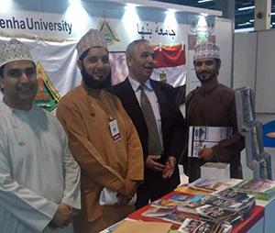
The pavilion of Benha University in the International Exhibition on Higher Education 2016 in Oman has attracted a large number of students to ask about education programs in the Egyptian universities.
In the same context, Prof. Dr. Gamal Ismail, the University Vice-president for Community Service and environment Development Affairs said the pavilion has attracted a large number of participants from various Arab countries to review and discuss the various education programs in Benha University indicating that more than 200 Arab and international universities and faculties participated in the Exhibition.

