Increasing the Reward of Education for Staff of Benha University

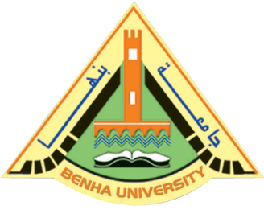
The Council of Benha University has approved under the presidency of Prof. Dr. Ali Shams El Din, the University President and in the presence of his Vice-presidents to increase the reward of Education for all staff of Benha University for 9 months from October to 30 June of each year instead of 2 months only.

