The Applying for the Scientific Research Supporting Program extended to the Middle of February 2016

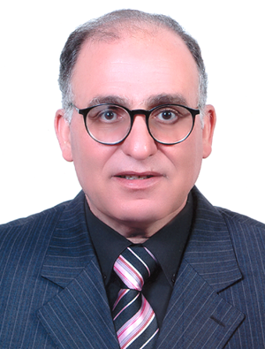
Prof. Dr. Maher Hasab El Naby Khalil, the Advisor to Benha University President for Scientific Research and the Supervisor of the Scientific Research Fund said that the Applying for the Scientific Research Supporting Program has been extended to the middle of February 2016 upon the desire of the University young researchers and faculty members.

