Benha University Delegation congratulates Qalyoubia Governor and Security Bodies on the Occasion of Police Day

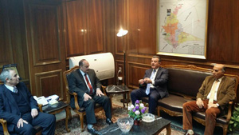
A delegation from Benha University under the presidency of Prof. Dr. Ali Shams El Din, the University President has visited Dr. Reda Farahat, the Governor of Qalyoubia to congratulate him and the security bodies on the occasion of Police Day.
It is worth mention that the delegation included Prof. Dr. Prof. Dr. Gamal Ismail, the University Vice-president for Community Service and Environment Development; Prof. Dr. Soliman Mustafa, the University Vice-president for Education and Students ' Affairs; and Prof. Dr. Hesham Abu El Enin, the University Vice-president for Postgraduate Studies and Researches ' Affairs.

.

