The Faculty of Arts announces the Results of Open Learning, First Term 2015/2016

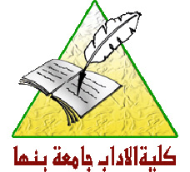
The Faculty of Arts, Benha University has announced the results of the first term 2015/2016 for the program of Open Learning wishing all success for all students.
You can see the results throughout the following link:
http://mis.bu.edu.eg/results/adab_result.aspx.

.

