The Board of Benha University Hostels discusses the Plan of Quality

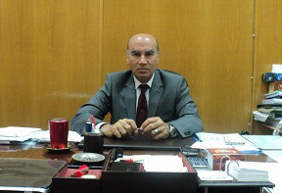
The Board of Benha University Hostels has discussed under the presidency of Prof. Dr. Soliman Mustafa, the University Vice-president for Education and Students’ Affairs the plan of the University Hostels for launching the quality and excellence in the work under the frame of the University strategic plan 2016/2022.

.

