Qalyoubia Governor and Benha University Vice-president inspect the University Hospital

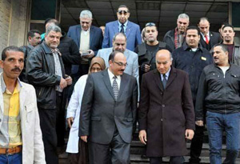
Dr. Reda Farahat, the Governor of Qalyoubia and Dr. Soliman Mustafa, the Vice-president of Benha University for Education and Students’ Affairs have inspected the Surgery Building at the University Hospital in addition to the Department Reception and Emergency after its renewing by providing the latest therapeutic devices.

.

