Workshop on “Supporting the Research Projects of Young Researchers and Its Output on Benha University”

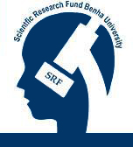
Prof. Dr. Maher Hasab El Naby Khalil, the Advisor to Benha University President for Scientific Research and the Supervisor of the Scientific Research Fund said that a workshop under the title of “Supporting the Research Projects of Young Researchers and Its Output on Benha University” will be held on Tuesday, 19/01/2016 at the Faculty of Engineering in Shubra under the auspices of Prof. Dr. Ali Shams El Din, the University President; Prof. Dr. Hesham Abu El Enin, the University Vice-president for Postgraduate Studies and Researches’ Affairs; and Prof. Dr. El Sayed El Kady, the Faculty Dean.

.

