Benha University Participates in the 3rd International Conference of Tempus Programme

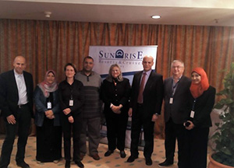
Under the auspices of Prof. Dr. Ali Shams El Din, the President of Benha University; Prof. Dr. Hesham Abu El Enin, the University Vice-president for Postgraduate Studies and Researches 'Affairs; a delegation from the Faculty of Agriculture under the presidency of Prof. Dr. Mahmoud Iraqy, the Faculty Dean has been participated in the 3rd International Conference of Tempus Programme held in the duration from 12/01/2016 to 15/01/2016 in Hurghada.

