Salon in Al-Ahram Foundation about “the Future of Higher Education Development in Egypt”

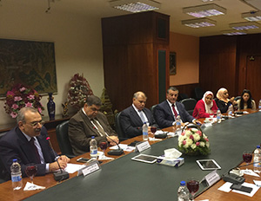
In the frame of the State institutions caring to develop the Higher Education in Egypt, a salon has been held in Al-Ahram Foundation about “the Future of Higher Education Development in Egypt” in the presence of Mr. Alaa Thabet, the Chief Editor of Al Ahram Massai; Dr. Ashraf Hatem, the Secretary General of the Supreme Council of Universities; Dr. Ali Shams El Din, the President of Benha University; Dr. Roshdy Zahran, the President of Alexandria University; and Dr. Yasser Sakr, the President of Helwan University.

