Benha University President heads the 1st Meeting of Faculty Members Club

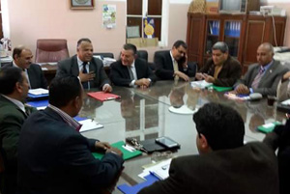
The Board of Benha University Faculty Members Club held its first meeting after the elections in the presence of Prof. Dr. Ali Shams El Din, the University President; Prof. Dr. Hesham Abu El Enin, the University Vice-president for Postgraduate Studies and Researches’ Affairs; Dr. Ezzat El Khayat, the Head of the Board; and Dr. Reda Omer, the Secretary General of the Club in addition to a number of faculty members.

