Benha University President discusses the Scientific Cooperation Ways with the German Embassy

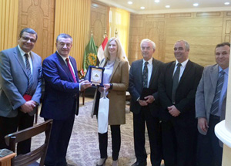
Prof. Dr. Ali Shams El Din, the President of Benha University has received Mrs. Laura Okzle, the Manager of the Protocol in the Embassy of Germany in Cairo in the presence of Prof. Dr. Gamal Ismail, the University Vice-president for Community Service and Environment Development Affairs; Prof. Dr. Soliman Mustafa, the University Vice-president for Education and Students’ Affairs; Prof. Dr. Hesham Abu El Enin, the University Vice-president for Postgraduate Studies and Researches ' Affairs; and Prof. Dr. Ghazy M.R. Assassa, the Advisor to the University President for Information Technology to discuss the scientific and academic cooperation ways with the Embassy in the various fields.

