Prof. Dr. Sameh Nada a Dean for the Faculty of Engineering in Benha

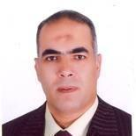
Benha University congratulates Prof. Dr. Sameh Mohamed Abdel Wahid Nada for his new position as a Dean for the Faculty of Engineering in Benha wishing all success for him in his new position.

