Medical Convoys for the Poorest Villages

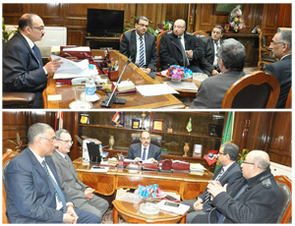
Prof. Dr. Hesham Abu El Enin, the University Vice-president for Postgraduate Studies and Researches’ Affairs; Prof. Dr. Ibrahim Rajeh, the Vice-dean of the Faculty of Medicine; and Prof. Dr. Mohamed Abdel Salam, the Director of the University Hospital have met General/ Reda Farahat, the Governor of Qalyoubia to make a medical convoys for the poorest villages of medical services upon the recommendations of Prof. Dr. Ali Shams El Din, the University President.

