Shams to MENA: Scientific Researches in the University by 23 Million EGP for the Development Issues

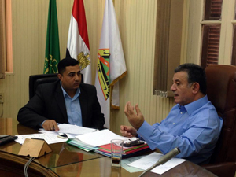
Nowadays, Benha University is celebrating with the 10th anniversary of its independence from Zagazig University and the 100th anniversary of its establishment as the first educational agricultural institution, so the Middle East News Agency “MENA” held an interview with Prof. Dr. Ali Shams El Din, the University President who has a major role in the University development.

