The New Qalyoubia Governor attends the University Council

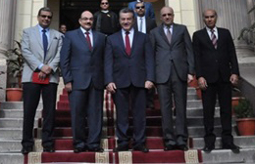
General/ Reda Farahat, the Governor of Qalyoubia has attended the council of Benha University which has been held under the presidency of Prof. Dr. Ali Shams El Din, the University President and in the attendance of Prof. Dr. Adel Adawy, the former Minister of Health; Prof. Dr. Soliman Mustafa, the University Vice-president for Education and Students’ Affairs; and Prof. Dr. Hesham Abu El Enin, the University Vice-president for Postgraduate Studies and Researches’ Affairs.

