Benha University participates in the Conference for AEAS

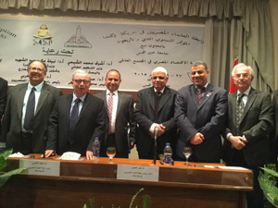
In the frame of Benha University openness to the academic world, the University participates in the Conference for the Association of Egyptian-American Scholars in the United States and Canada “AEAS” which will be held in Ain Shams University during the duration from Sunday, 27/12/2015 to Tuesday, 29/12/2015. The University will be represented by Prof. Dr. Ghazy M.R. Assassa, the Advisor to the University President for Information Technology.

