Benha University President in a Meeting with the Young Researchers

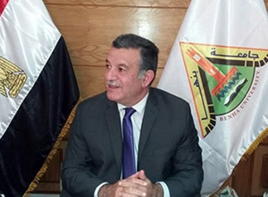
Prof. Dr. Ali Shams El Din, the President of Benha University has met the young researchers of the University faculties during the workshop of “Supporting the Research Projects of Young Researchers and Its Output on Benha University”. His Excellency said that the University scientific research sector has 35 research groups in the various fields and other 20 groups will be included in January 2016.

